STRIKE ACTION – REMOTE LEARNING: YEAR 1

Dear parents/carers,

As you are aware, the school will be closed on Wednesday 1 February 2023 due to strike action. It is important to understand that the action has nothing to do with Cyril Jackson Primary School but is a national dispute between the Union and the Government.

To access resources and activities for Year 1 pupils, please visit the school website and select ‘Parents & Carers’, then select ‘Year Groups’, and finally select ‘Year 1’, scroll down to the new Strike Action section. Alternatively, please follow this link:

https://www.cyriljackson.towerhamlets.sch.uk/parents/year1

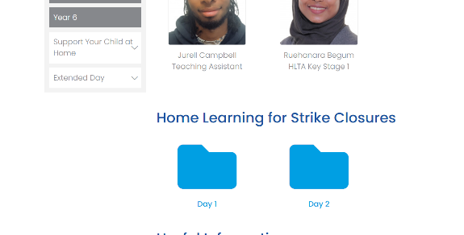
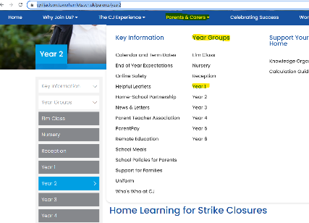
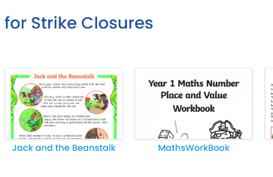

Please accept my apologies for any disruption that these arrangements may cause you, but we have done everything possible to limit this. We hope that you understand these decisions have been taken to secure the health and safety of your child(ren) and any non-striking staff.

As ever, thank you for your continued support.

Yours sincerely,
Hodo Dirir
Headteacher

